Step 2 – Multiple Sequence Alignment
In this task:
A separate protein-level alignment will be performed for functional species to identify conserved active-site residues, particularly the FAD-binding domain, which we will then check for disruption in the human pseudogene.
- Align GULO proteins from functional species.
- Find conserved residues (especially the FAD-binding domain).
- Human Analysis.

Step 1 – Collect functional GULO protein sequences -> Protein CDS.txt
- Go to NCBI Protein:
https://www.ncbi.nlm.nih.gov/protein
- Search:
GULO Rattus norvegicus
- Click the entry labeled:
- gulonolactone oxidase
- Click FASTA
- Copy everything, including:
>sp|... description
SEQUENCE...
- Repeat for each species

These proteins are functional enzymes. Evolution has preserved their important regions. If multiple species share the same amino acids, then those positions are critical for function.
Step 2 – Perform MSA -> clustal MSA.txt
Proteins only function if specific amino acids are in specific positions. If evolution keeps a certain residue unchanged, then this residue is essential.
- Go to Clustal Omega:
https://www.ebi.ac.uk/Tools/msa/clustalo/
- Paste all sequences
- Click Run
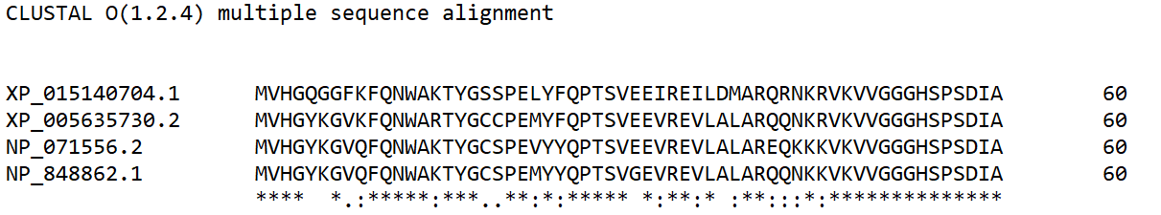
- Wait for output
Now we scan for highly conserved regions…
We look for long stretches of * these regions are functionally critical. If they are mutated, the protein stops working.
These are likely active sites, binding domains, structural cores…
Observations:
The alignment shows:
  - Very high conservation across all 4 species.
  - Lots of * identical residues.
  - Very few gaps proteins are structurally similar.
  - These proteins are homologous and functionally conserved enzymes (GULO) across species.

Step 3 – Identify the FAD-Binding domain FAA Binding.png
Now we try to identify the specific functional domain responsible for the enzyme activity.

! GULO is an oxidoreductase enzyme that:
- Uses a molecule called FAD (Flavin Adenine Dinucleotide)
- FAD is essential for the chemical reaction
Without FAD binding → enzyme is DEAD

How to find the domain
- Go to UniProt:
https://www.uniprot.org/
- Search:
GULO Rattus norvegicus
- Open the correct entry:
Click the one that says something like:
- L-gulonolactone oxidase
- Organism: Rattus norvegicus
- Find the domain information
Scroll down slowly and look for sections like:
- “Function”
- “Domains and Repeats”
- “Family & Domains”
- “Sequence annotations (Features)”
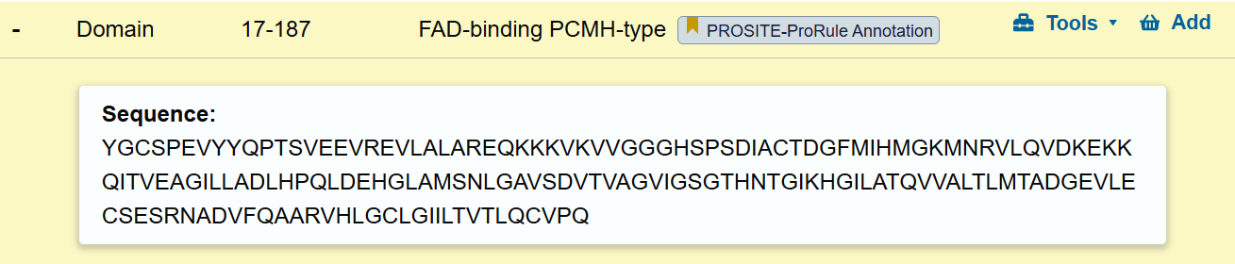
Result:

Step 4 – Map it into our Alignment
Notice that positions 17-187 are highly conserved in all the sequences.
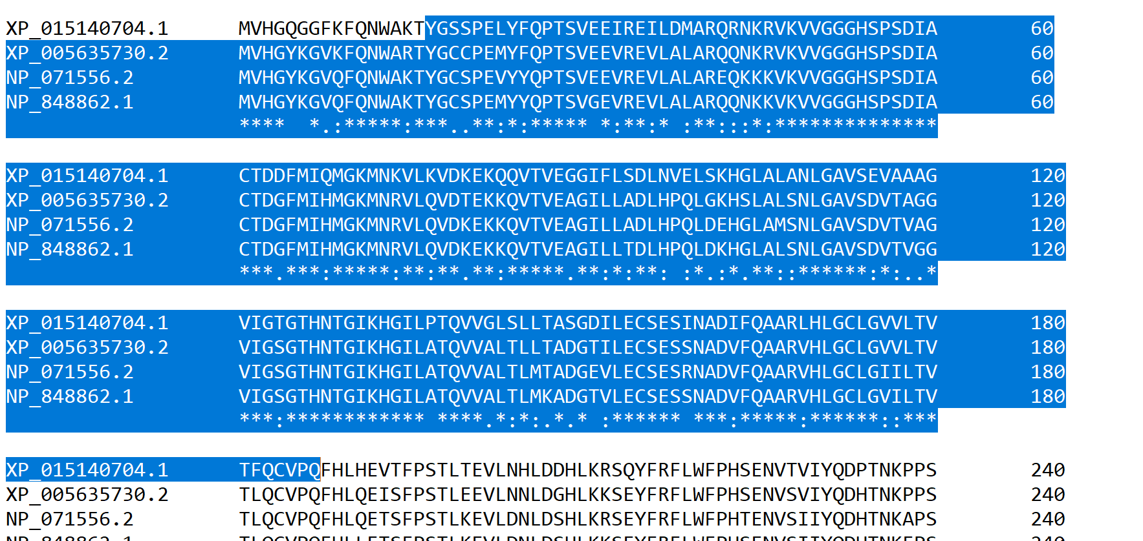
The residues are:
  - Identical across species.
  - Highly conserved.
  - these particular amino acids are required for proper functioning.

Step 5 – Compare with Human Pseudogene

Humans carry a GULO pseudogene on chromosome 8. No functional protein is produced from this gene due to multiple premature stop codons and frameshift mutations.

In contrast to functional GULO proteins in other mammals, humans lack the FAD-binding domain entirely due to gene disruption. This demonstrates the molecular basis for the loss of Vitamin C synthesis in humans.
Our analysis of conserved residues and the human pseudogene highlights that the inability of humans to synthesize Vitamin C is directly linked to the inactivation of the GULO gene, specifically the loss of the critical FAD-binding domain.

